Radar Live — MQS Monitoring & Alerting Pipeline
Technical & Functional Documentation
Handover Pack — Service Excellence / Maintenance Team

Covers three Databricks/PySpark jobs:
Bronze 30-min Monitoring · Interaction Status Monitoring · SLA Alert / Notification

Document version 1.0

1. Purpose of This Document
This pack documents the three production jobs that make up the Radar Live MQS monitoring and alerting pipeline, so the Service Excellence / Maintenance team can support, troubleshoot, and extend them without needing the original developer. It covers what each job does, how it decides what to process, the tables it reads and writes, and the operational behaviour to expect day to day (including on-call scenarios).
The three jobs in scope are:
- Job 1 — Bronze 30-min Monitoring: counts raw MQS messages per source table, per 30-minute interval, per brand.
- Job 2 — Interaction Status Monitoring: joins two eHub streams to track interaction status volumes per interval and brand.
- Job 3 — SLA Alert / Notification: reads the outputs of Jobs 1 and 2 (plus an external EHUB table), decides whether the pipeline is in breach, and posts Adaptive Card alerts to a Microsoft Teams channel.

2. System Architecture
All three jobs run on a fixed cadence — every 30 minutes — aligned to the same interval boundaries. Jobs 1 and 2 are independent producers that land data into their own Delta tables; Job 3 is a consumer that reads across all monitoring tables and owns the alerting decision and notification state.
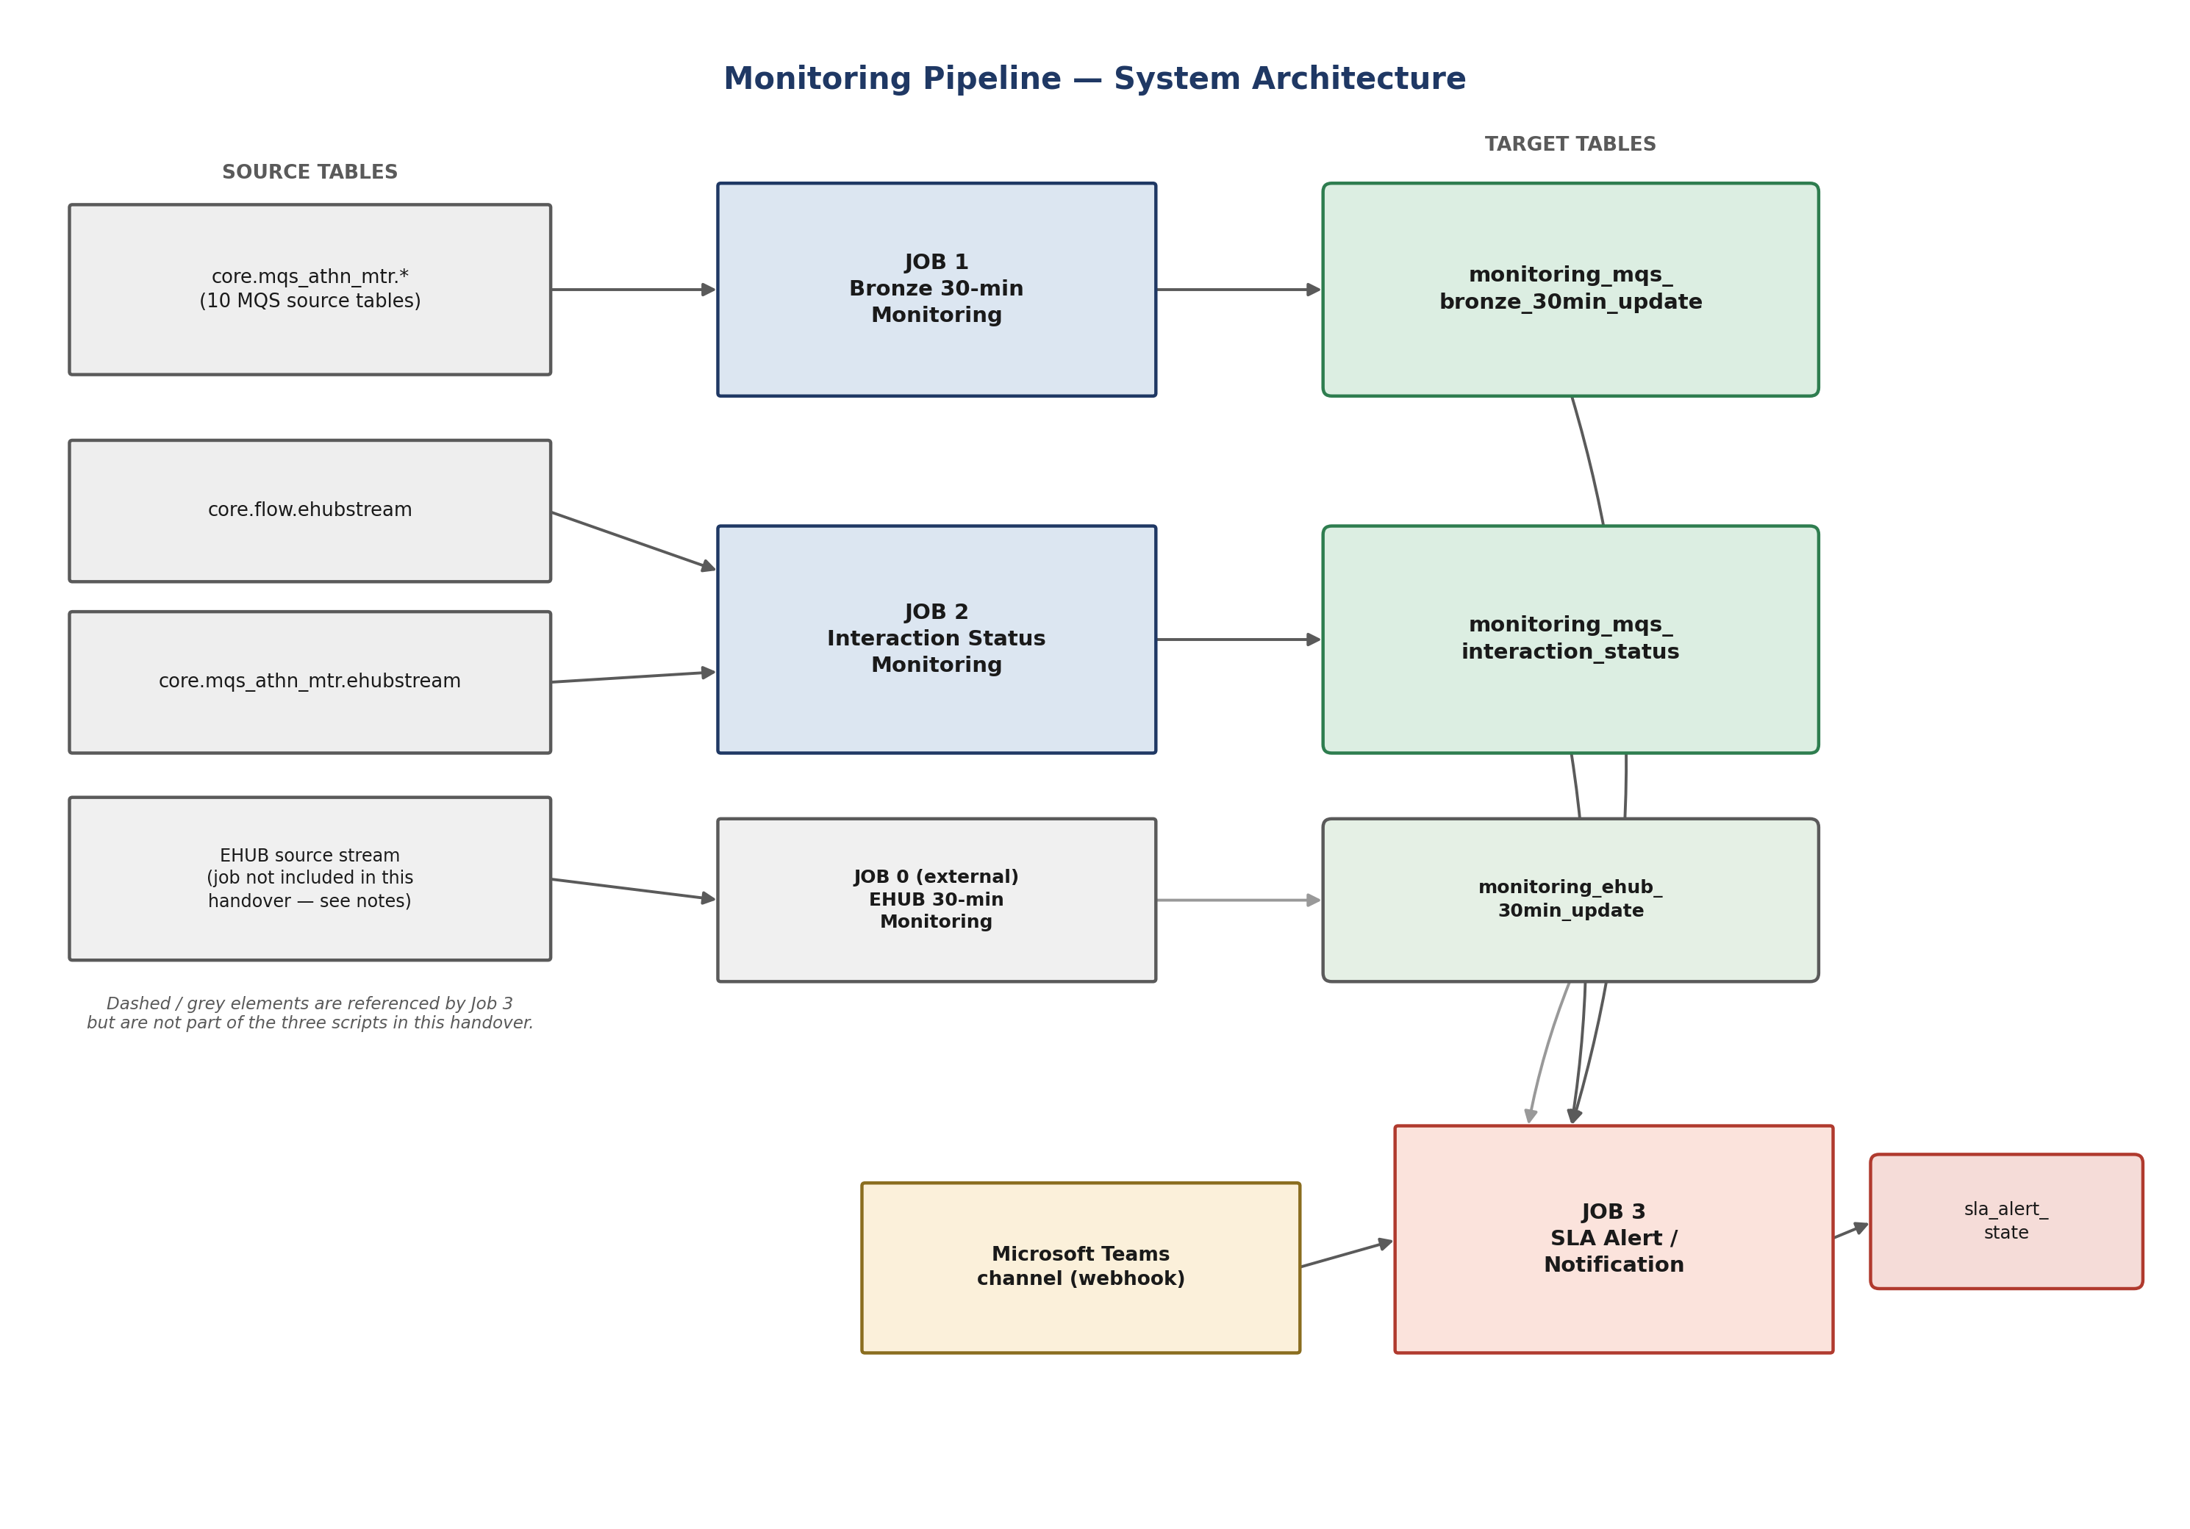
Figure 1 — End-to-end data flow from source tables through the monitoring jobs to Teams alerts.
Note — EHUB table dependency:
Job 3 reads from core_bld.default.monitoring_ehub_30min_update, but the job that populates this table was not included in the three scripts reviewed for this handover. It appears to follow the same pattern as Job 1 (Bronze) against a different EHUB source. Confirm ownership and location of that job with the original team before relying on Job 3 in production — if it stops running, Job 3's breach detection for the EHUB side will silently go stale.

3. Job 1 — Bronze 30-min Monitoring

3.1 Purpose
Counts messages landing in 10 raw MQS Delta tables (quote requests, rating requests/responses, cache IDs, precomp responses, enrichments, underwriting results, DVLA-removed requests, pricing results, stop-quotes) for every 30-minute interval and brand, and flags intervals where an expected brand produced zero messages (an SLA breach) or where traffic appears under an unrecognised brand.

3.2 Key configuration
Parameter | Value | Notes
TARGET_TABLE | core_bld.default.monitoring_mqs_bronze_30min_update | Delta table, partitioned by run_date
INTERVAL_MINUTES | 30 | Bucket size for all aggregation
RETENTION_DAYS | 2 | Rows older than this are deleted every run
PREFER_ENQUEUED_TIME | True | Uses enqueuedTime column when present, else eHubQueuedDatestamp
EXPECTED_BRANDS | AZ, GSF | Brands that must have traffic every interval
SPINE_BRANDS | AZ, GSF, OTHER | Used to build the full interval × brand grid
SOURCE_TABLES | 10 tables under core.mqs_athn_mtr | See §3.1

3.3 Run-mode selection
Every run first decides which time window to (re)process. This logic is identical in Job 2.
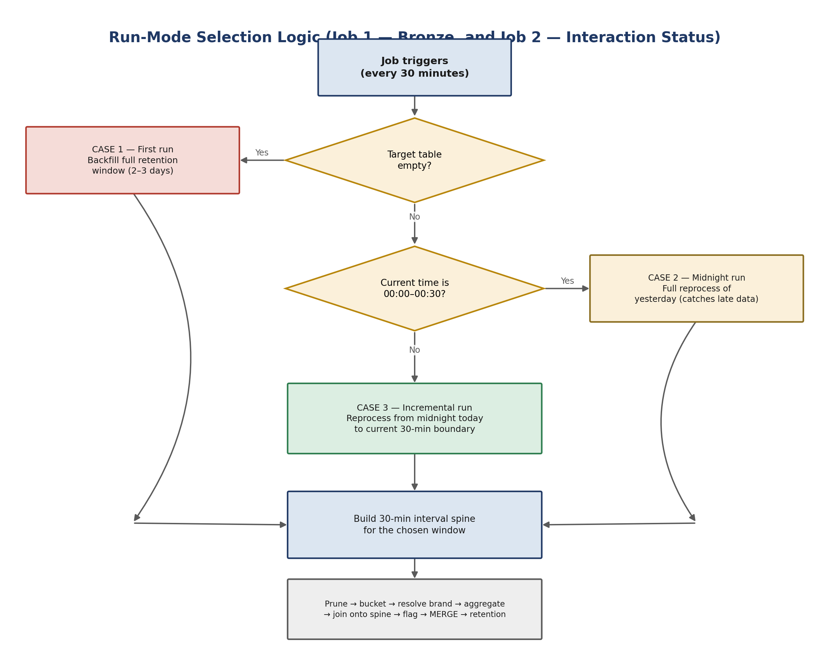
Figure 2 — Run-mode decision tree, shared by Jobs 1 and 2.
- Case 1 — First run: target table is empty → backfill the full retention window (2 days for Job 1).
- Case 2 — Midnight run (00:00–00:30): full reprocess of yesterday, to pick up any late-arriving data.
- Case 3 — Normal incremental run: reprocess from midnight today up to the current 30-minute boundary. This is deliberately wider than “just the last interval” so every slot since midnight always has a placeholder row, even with zero traffic.

3.4 Per-table processing logic
For each of the 10 source tables the job runs the same pipeline independently, then unions all results before the final merge:
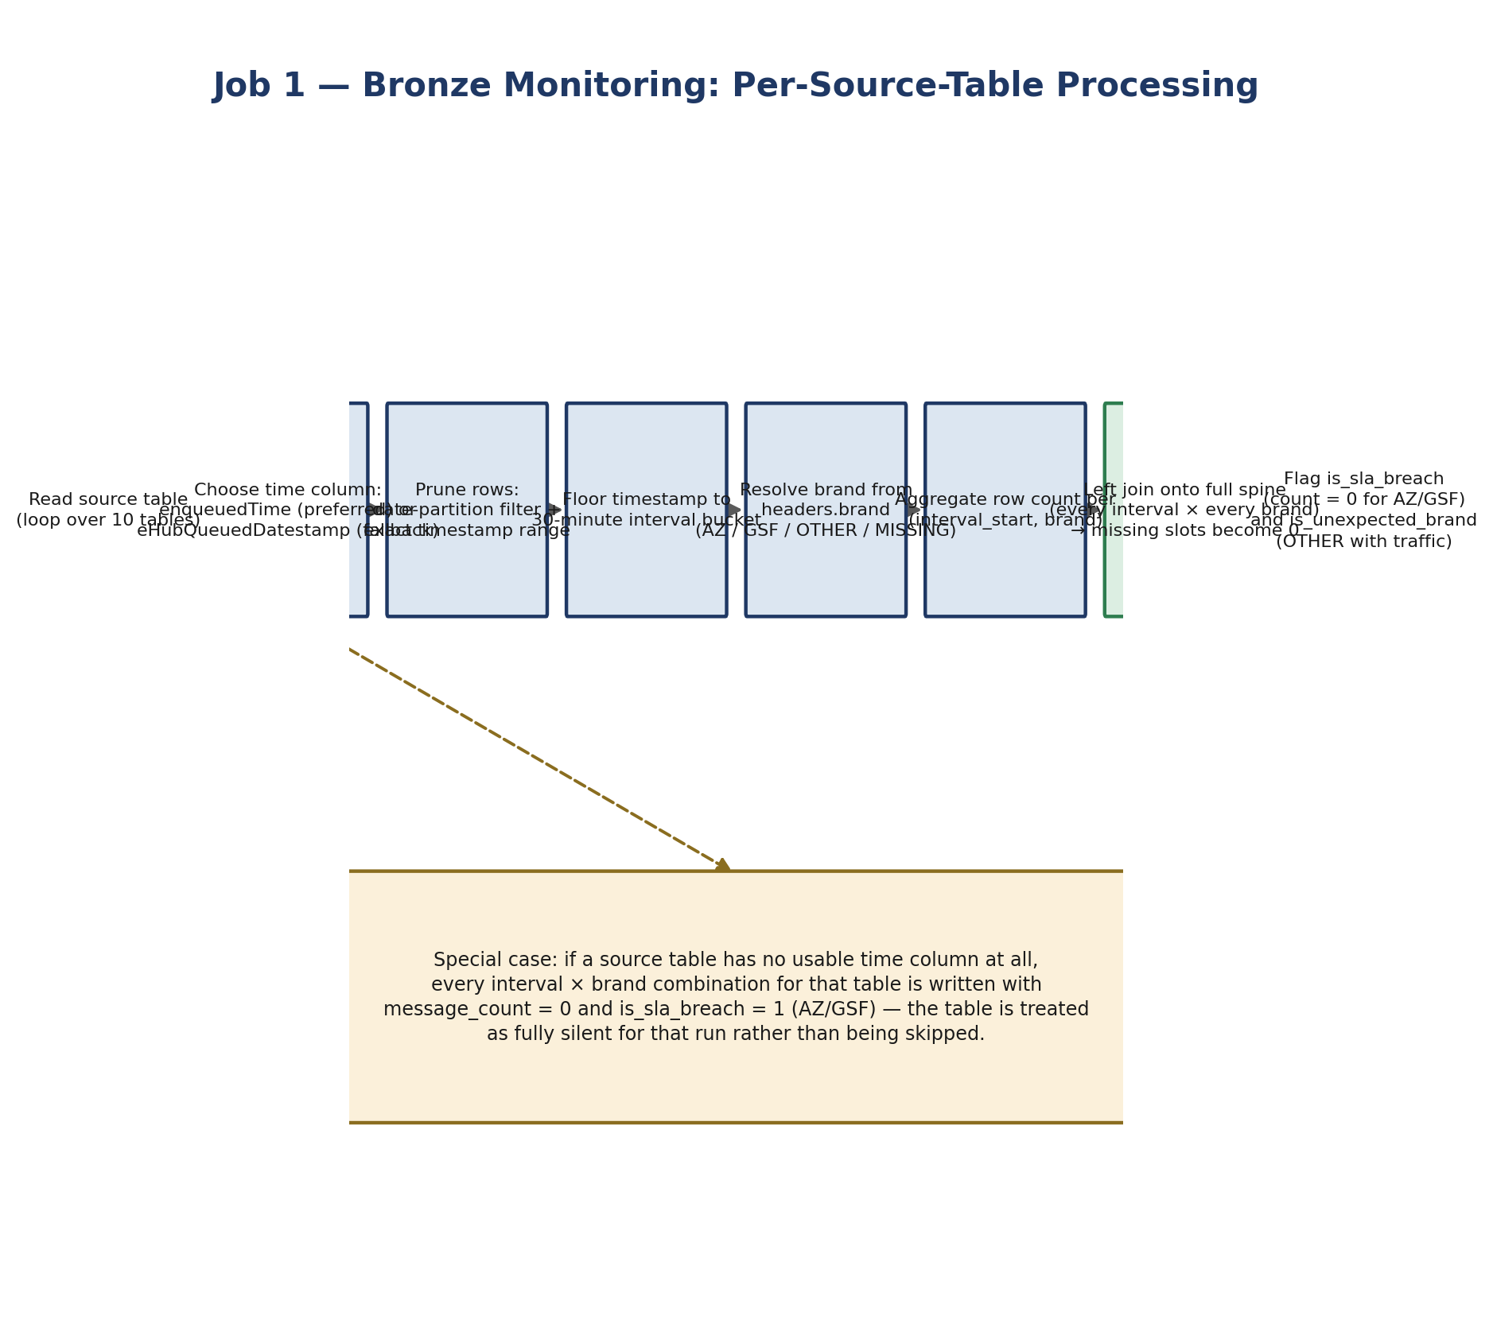
Figure 3 — Per-source-table processing steps.

Brand resolution
Brand is read from the headers.brand field (or a headers.brand top-level column if the struct isn't present). AZ and GSF are mapped through as-is; a null value is mapped to MISSING_INTERACTION_BRAND; anything else is mapped to OTHER. If a source table has no brand column at all, every row is treated as MISSING_INTERACTION_BRAND.

Output schema
Column | Type | Description
run_date | DATE | Partition column, date of interval_start
interval_start / interval_end | TIMESTAMP | 30-minute bucket boundaries
message_type | STRING | Source table short name, e.g. dlt_quote_request
brand | STRING | AZ / GSF / OTHER / MISSING_INTERACTION_BRAND
message_count | BIGINT | Row count for that interval + message_type + brand
is_sla_breach | INT | 1 when count = 0 for AZ or GSF in that slot
is_unexpected_brand | INT | 1 when brand = OTHER and count > 0

4. Job 2 — Interaction Status Monitoring

4.1 Purpose
Tracks interaction status volumes (e.g. counts per status value) by joining the customer-facing eHub flow stream to the MQS eHub stream on quote and interaction identifiers, so that status transitions can be monitored per brand and per 30-minute interval, independent of the raw Bronze message counts.

4.2 Key configuration
Parameter | Value | Notes
SOURCE_FLOW_TABLE | core.flow.ehubstream | Payload JSON with interaction status, brand, timestamp
SOURCE_MTR_TABLE | core.mqs_athn_mtr.ehubstream | Header-based quote/interaction IDs, used to join
TARGET_TABLE | core_bld.default.monitoring_mqs_interaction_status | Delta table, partitioned by run_date
RETENTION_DAYS | 3 | Longer retention than Job 1
BRAND_NAME_MAP | Britannia→GSF, AllianzOnline→AZ | Primary brand resolution source
GENERATION_CODE_MAP | GSF01→GSF, FLOWAN01/02→AZ | Fallback when brandName is null

4.3 Brand resolution priority
- 1. If payload brandName is present and recognised → mapped brand; if present but unrecognised → OTHER.
- 2. Else if generationCode is present and recognised → mapped brand; if present but unrecognised → OTHER.
- 3. Else (both null) → MISSING_INTERACTION_BRAND.

4.4 Join logic
The FLOW stream provides the event timestamp, status and brand; the MTR stream provides the identifiers used to confirm the interaction is a genuine MQS-linked event. Only rows that match on both mqs_quote_id and interaction_id are counted.
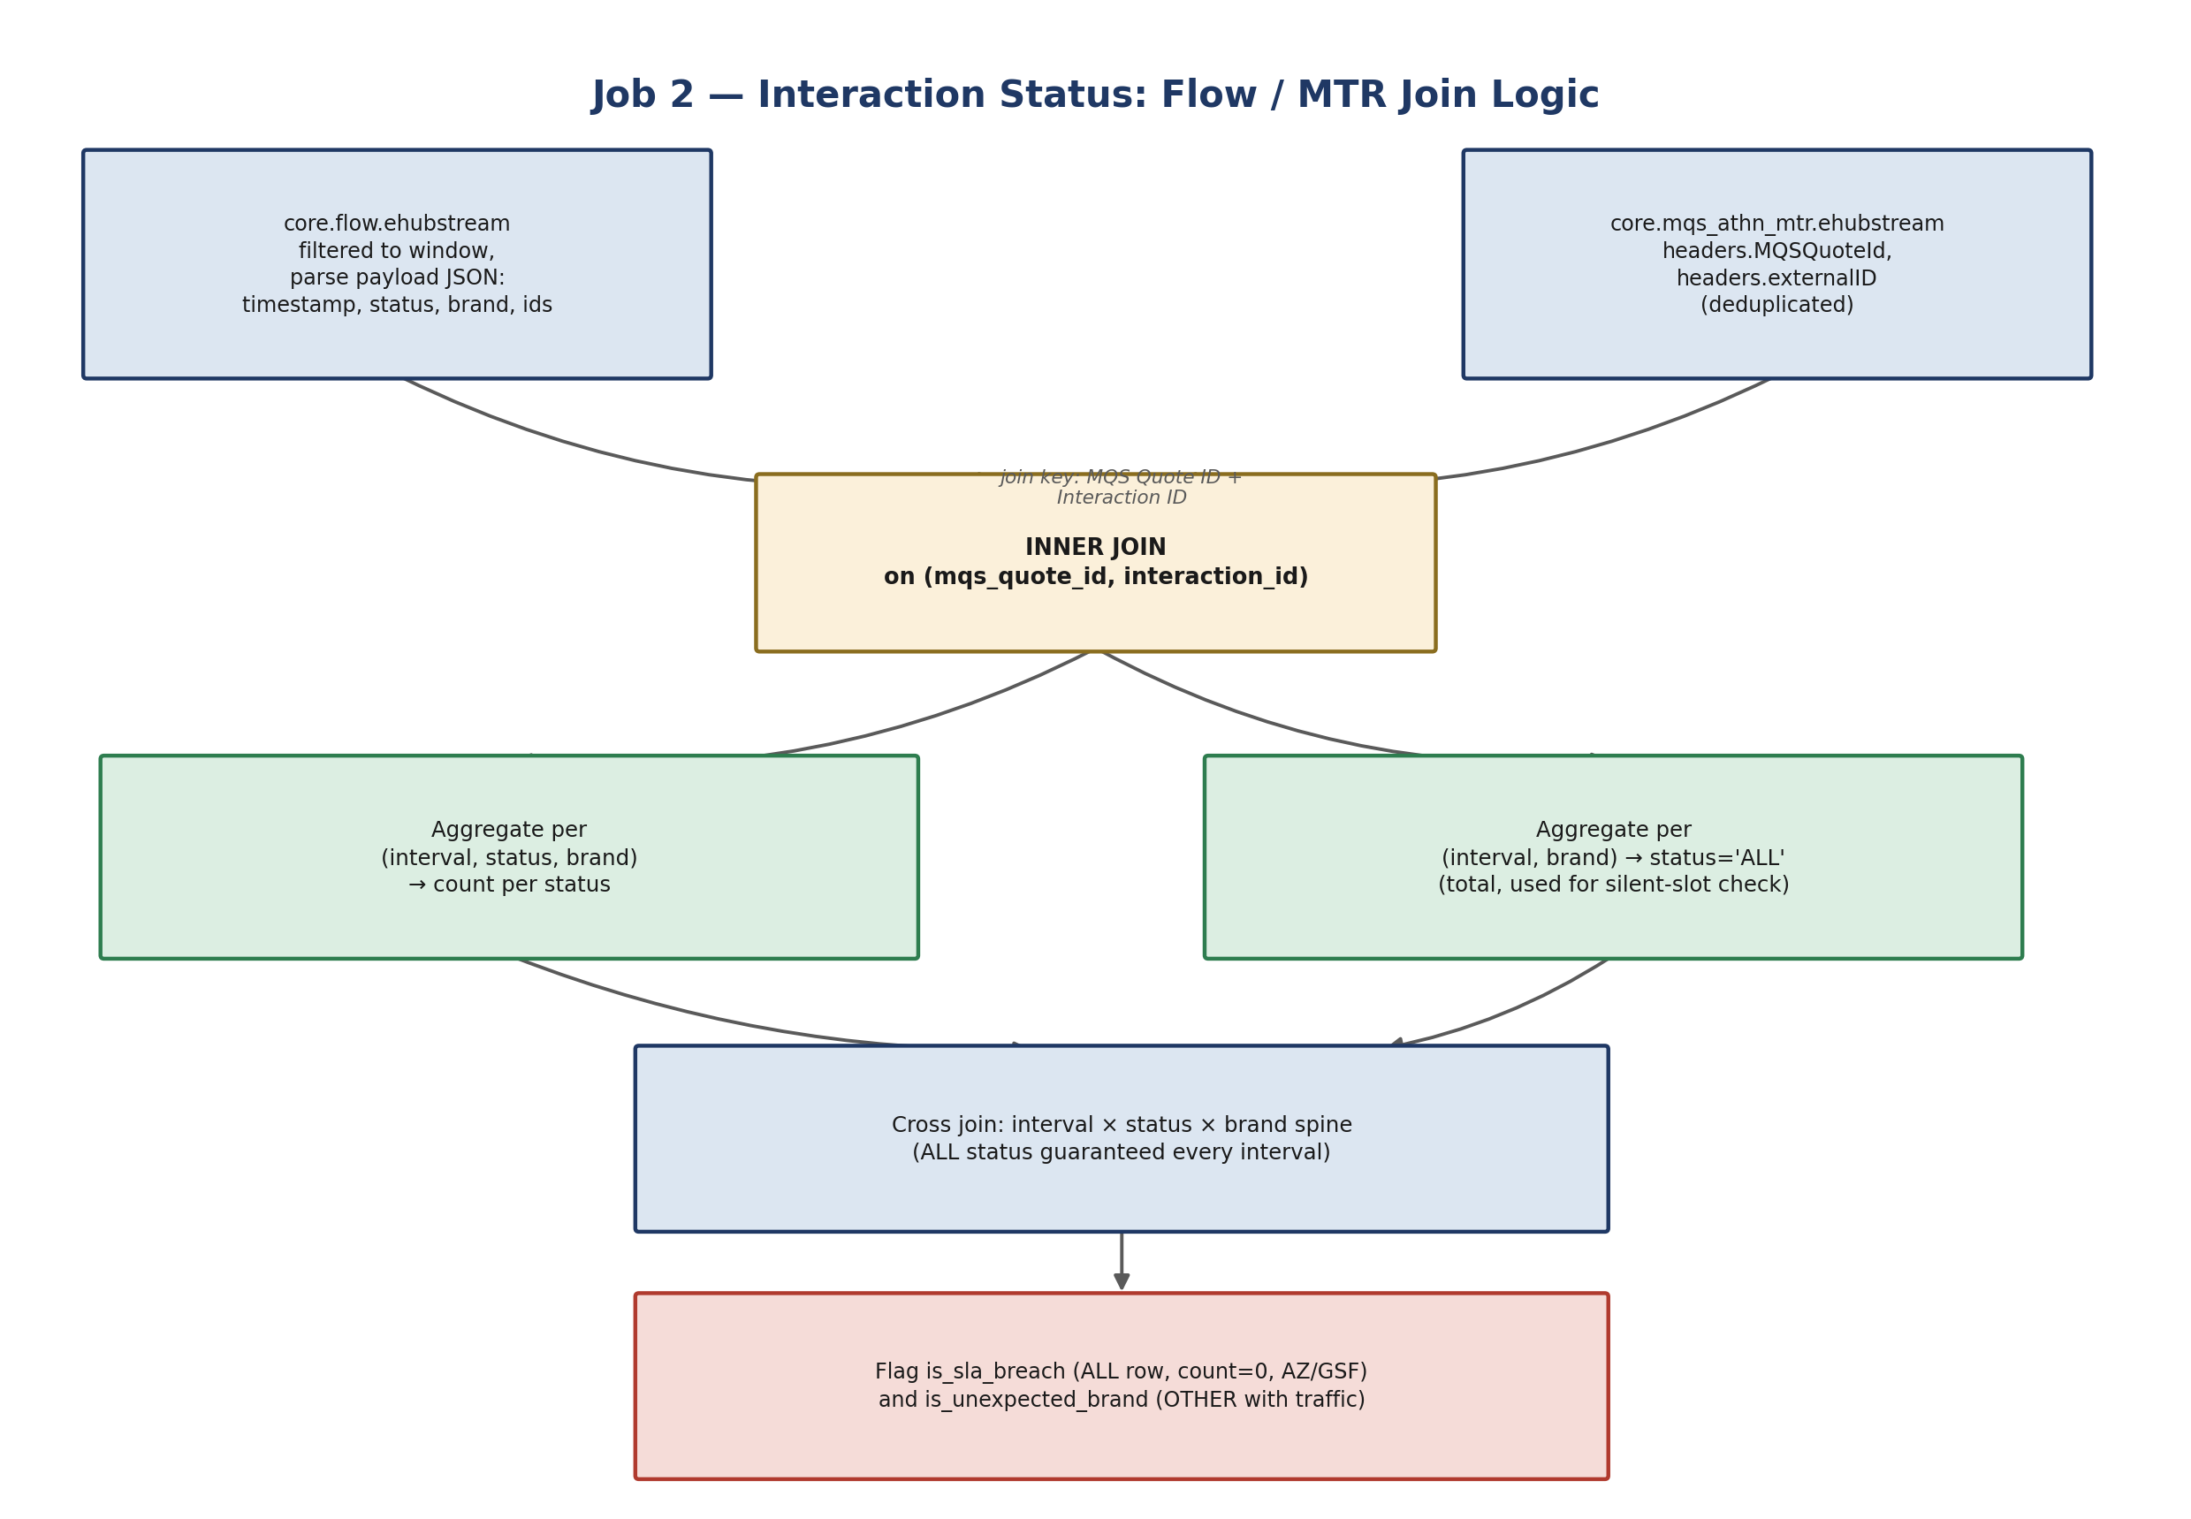
Figure 4 — Flow / MTR join and aggregation.

The ALL status row
In addition to a row per distinct status value, the job always writes a status = 'ALL' row per interval and brand, representing total interaction volume regardless of status. This ALL row is what Job 3 uses to detect a fully silent interval (zero interactions of any status), even if individual status values don't line up.

Output schema
Column | Type | Description
run_date / interval_start / interval_end | DATE / TIMESTAMP | Standard interval columns
status | STRING | Interaction status value, or 'ALL' for the total row
brand | STRING | AZ / GSF / OTHER / MISSING_INTERACTION_BRAND
total_count | BIGINT | Count of matched interactions
is_sla_breach | INT | 1 on the ALL row when total_count = 0 for AZ/GSF
is_unexpected_brand | INT | 1 when brand = OTHER and total_count > 0

5. Job 3 — SLA Alert / Notification

5.1 Purpose
Reads the settled (fully written) interval across the EHUB, Bronze and Interaction Status tables, decides whether the pipeline is currently in breach, and sends Adaptive Card alerts to a Microsoft Teams channel. It also sends a separate daily health summary each morning. State is persisted so alerts are debounced — breaches fire immediately, but recovery only fires after a sustained healthy period.

5.2 Key configuration
Parameter | Value | Notes
STATE_TABLE | core_bld.default.sla_alert_state | One row per ALERT_NAME, tracks notification state
BREACH_CONFIRM_INTERVALS | 1 | Breach alerts are sent on first detection
RECOVERY_CONFIRM_INTERVALS | 3 | Requires 3 consecutive healthy intervals (~1.5 hrs) before recovery alert
DAILY_HEALTH_HOUR | 7 | Daily summary card sent 07:00–07:30
WEBHOOK_MAX_RETRIES / DELAY | 3 / 10s | Retries on HTTP 403 / 429 / 5xx / timeout / connection error

5.3 Settled interval
Rather than evaluating the most recent 30-minute slot (which may still be mid-write by Jobs 1/2), Job 3 evaluates the second-to-last completed interval each run. This avoids false breaches caused purely by timing, at the cost of alerts lagging real time by up to one interval.

5.4 Breach detection
For the settled interval, Job 3 joins EHUB and Bronze counts by message type and brand, and checks total interaction volume. A row is treated as a breach if any of the following is true:
- EHUB flags an SLA breach for that message type/brand (zero count for AZ/GSF), or
- Bronze flags an SLA breach for the equivalent message type/brand, or
- Total interaction count for the interval (from the Interaction Status ALL row) is zero.

5.5 Decision logic & state machine
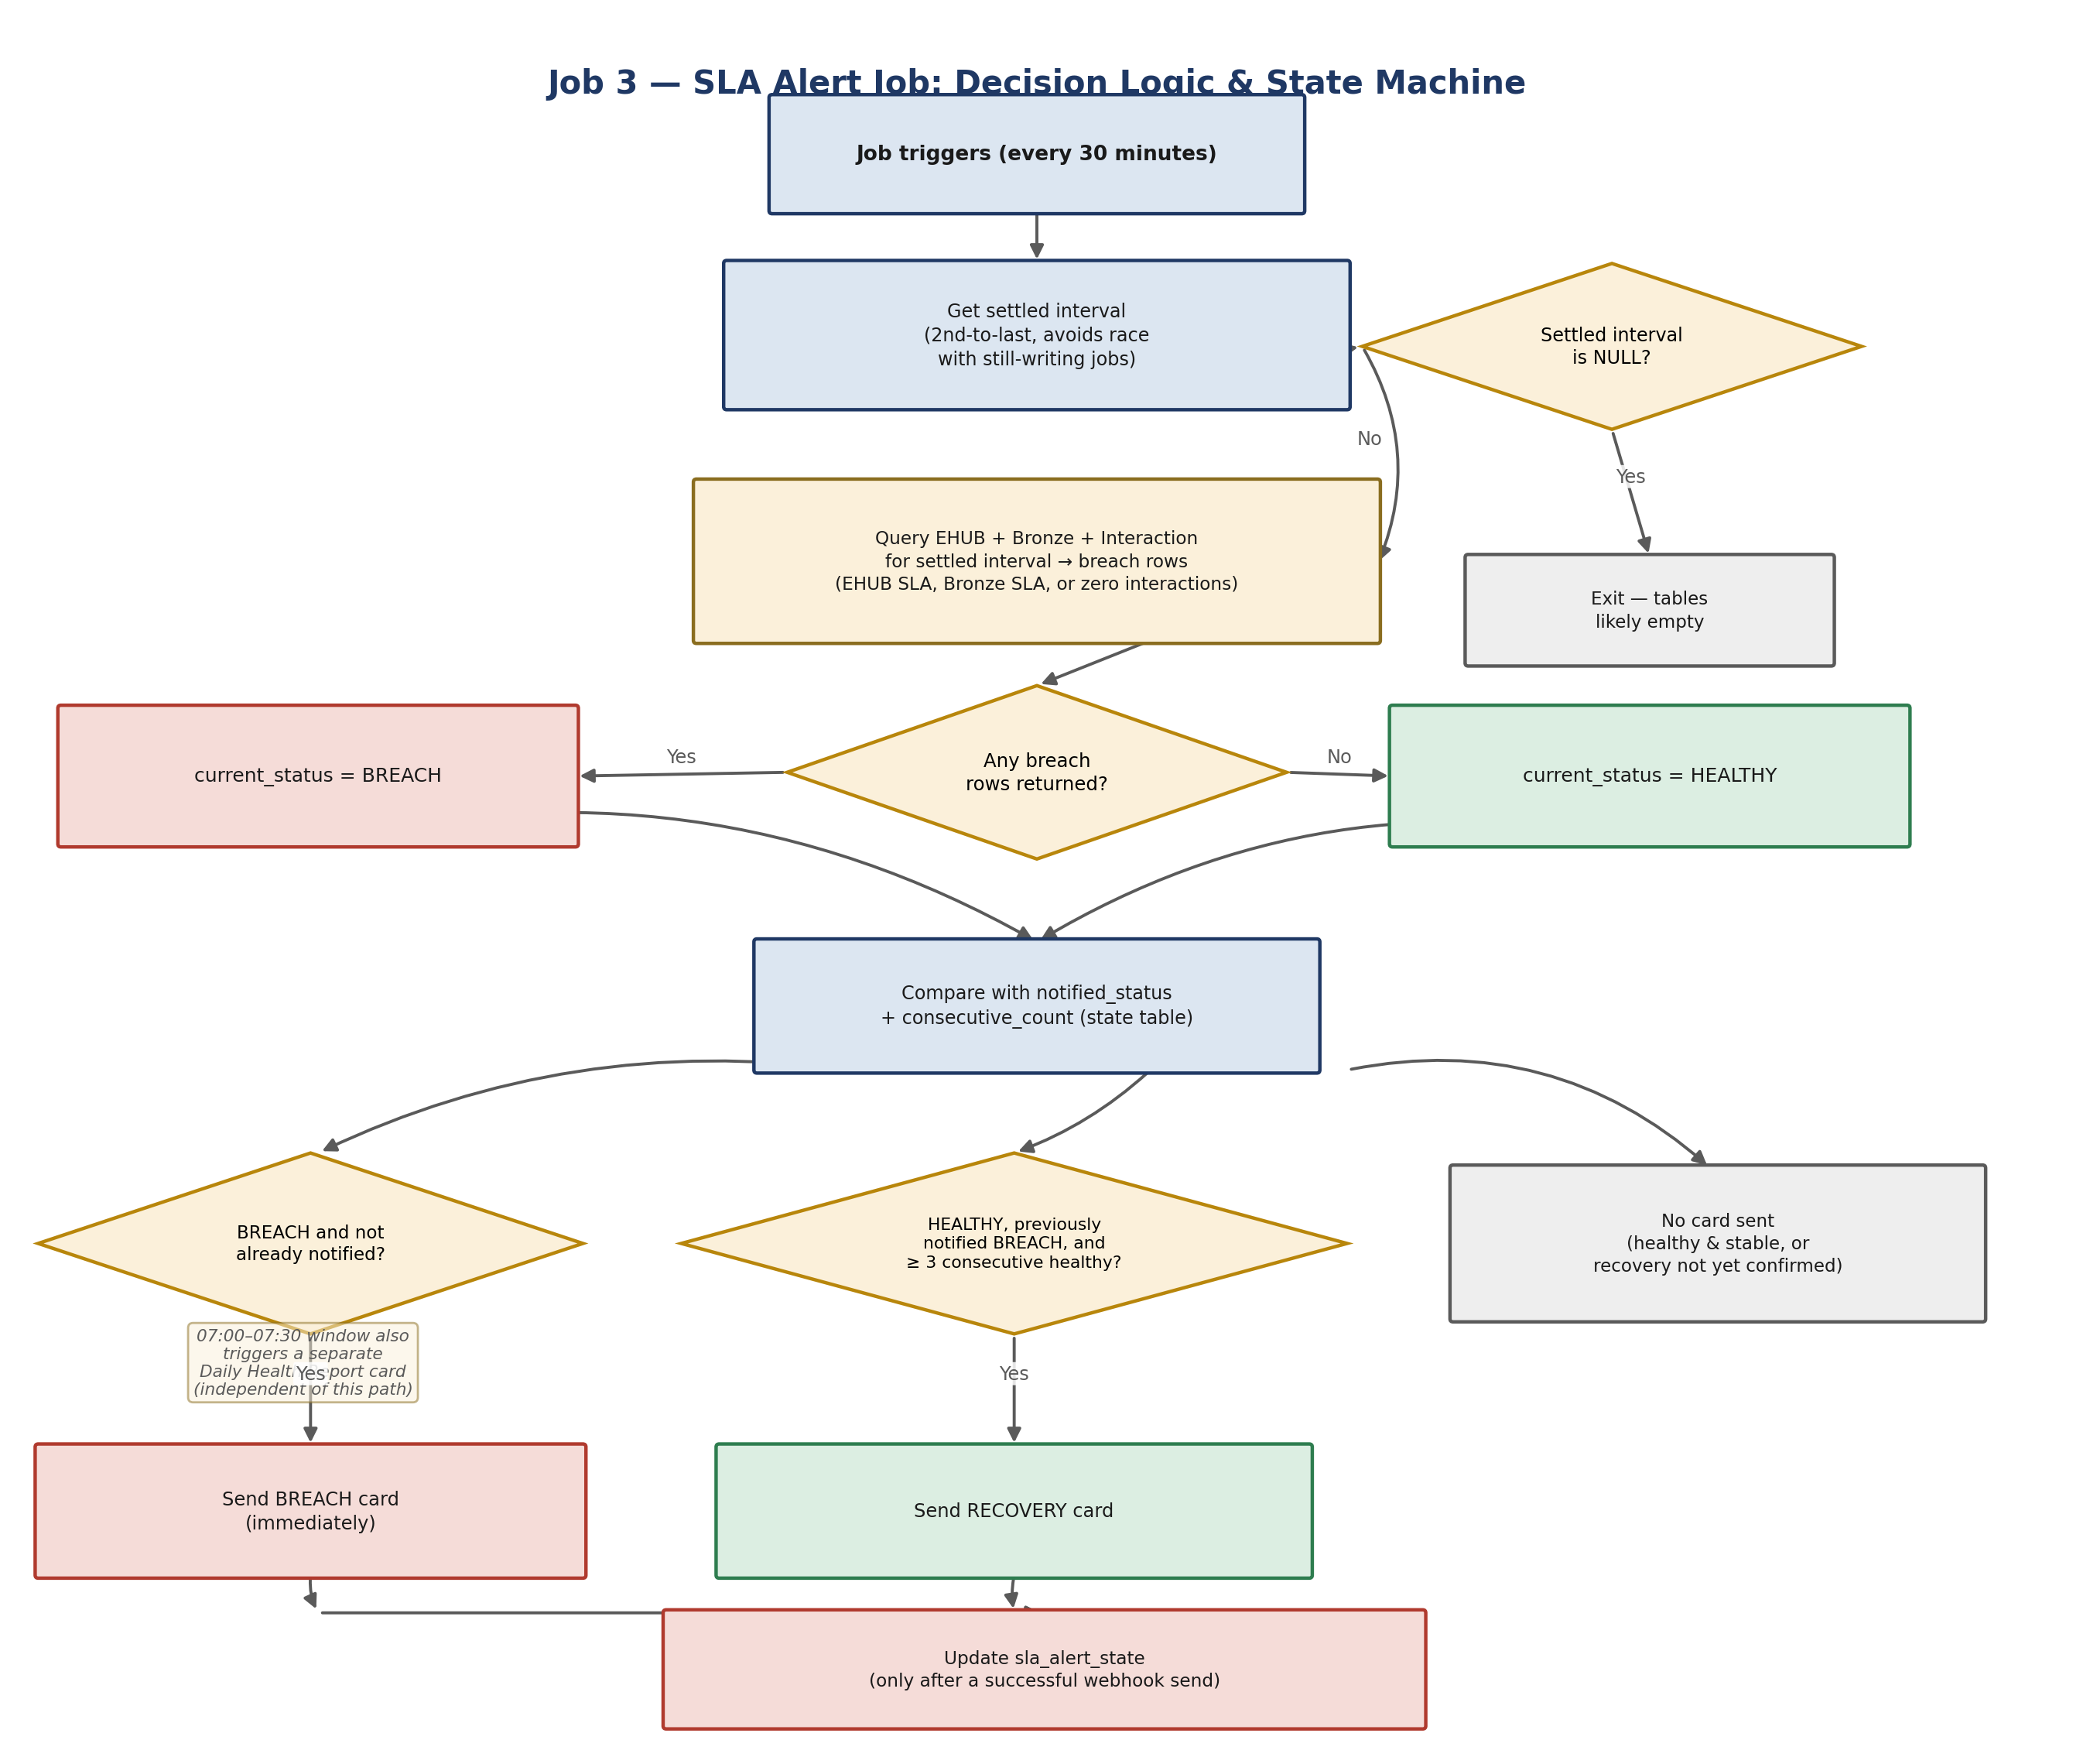
Figure 5 — End-to-end alert decision flow for a single run.

Card types
Card | Trigger | Content
Breach card (🔴) | current_status = BREACH and not already notified | Impacted flows table: brand, message type, EHUB count, Bronze count, diff, breach source
Recovery card (✅) | current_status = HEALTHY, previously notified BREACH, ≥ 3 consecutive healthy intervals | Confirms recovery and restates verification basis
Daily health card (📊) | Run falls in the 07:00–07:30 window | Per-brand status and count of breach intervals since midnight

Webhook delivery & state consistency
Webhook posts retry up to 3 times (10s apart) on 403 / 429 / 5xx / timeout / connection errors. If all retries fail, the state table is deliberately left unchanged so the next run re-detects and re-attempts the same alert — no breach or recovery notification is ever silently lost due to a transient webhook failure. When no card needs to be sent, the state table is still updated every run to keep the consecutive-healthy counter accurate.

State table schema
Column | Description
alert_name | Fixed value 'radar_live_sla_monitor' (single logical alert)
current_status | Most recently evaluated status: BREACH or HEALTHY
notified_status | Status last actually communicated to Teams
consecutive_count | Consecutive runs at current_status, used for recovery debounce
last_interval / last_notified_at | Audit fields for the last evaluated interval and update time

6. Dependencies, Assumptions & Known Gaps
- The EHUB 30-min monitoring job that populates monitoring_ehub_30min_update is not part of this handover's source scripts. It must exist and run on the same 30-minute cadence for Job 3 to function — confirm its schedule and ownership separately.
- All three jobs assume the Databricks cluster clock and current_timestamp() reflect the correct local run time; is_start_of_day() and is_daily_health_window() both key off datetime.now(), not a Spark server-side timestamp, so cluster timezone configuration matters.
- The webhook URL and dashboard URL in Job 3 are placeholders in the reviewed script (WEBHOOK_URL = "xxx", DASHBOARD_URL = "yyy") — confirm the live values are correctly set in the deployed job configuration, not hardcoded as shown.
- Brand mapping in all three jobs is a fixed, hardcoded list (AZ, GSF, plus source-specific raw-value maps in Job 2). A new brand or a source system renaming its raw brand value will land as OTHER or MISSING_INTERACTION_BRAND and will not automatically self-correct — this requires a code change.
- Bronze retention is 2 days; Interaction Status retention is 3 days. Job 3's overnight breach counts and recovery logic only ever look back to the start of the current day, so this asymmetry does not affect alerting, only how far back the raw monitoring tables can be queried for investigation.

7. Operational Runbook

7.1 Daily / routine checks
- Confirm all three jobs completed successfully in the scheduler (each prints a final “...completed successfully.” line to job logs).
- A daily health card should appear in the Teams channel between 07:00 and 07:30. If it doesn't, check Job 3 ran in that window and that is_daily_health_window() evaluated true.

7.2 “We got a breach alert — what do I check?”
- Open the breach card in Teams — it lists brand, message type, EHUB count, Bronze count, diff, and a breach source tag (△ EHUB, △ BRONZE, △ EHUB & BRONZE, or ※ INTERACTION).
  - △ EHUB / △ BRONZE / △ EHUB & BRONZE: the named table saw zero messages for that brand/message type in the settled interval — check the corresponding upstream source table for ingestion problems.
  - ※ INTERACTION: total interaction volume was zero across all statuses — check the flow/MTR join in Job 2 (identifier mismatches between the two streams are a common cause of interactions silently dropping out of the join).
- Cross-check against monitoring_mqs_bronze_30min_update / monitoring_mqs_interaction_status / monitoring_ehub_30min_update directly in a notebook, filtering to the interval_end shown on the card.

7.3 “No recovery alert after a fix”
This is expected behaviour, not a bug: recovery requires 3 consecutive healthy settled intervals (about 1.5 hours) after a breach before Job 3 sends the recovery card. Check consecutive_count in sla_alert_state — it should be climbing toward 3 each run.

7.4 “Alert seems stuck / duplicated”
- Query core_bld.default.sla_alert_state — there should be exactly one row for alert_name = 'radar_live_sla_monitor'.
- If notified_status is stuck at BREACH despite genuinely healthy data, verify Job 3's webhook is succeeding (check job logs for “All 3 attempts failed”) — on repeated webhook failure the state table is never updated, so the job will keep retrying the same breach alert every run until the webhook succeeds.
- If the state row is corrupted or you need to force a clean restart of the alerting state, it can be deleted or reset (with team sign-off) — the next run will re-derive current_status fresh and treat consecutive_count as starting from 1.

7.5 Backfill / first-run behaviour
If any target table is dropped and recreated, the next run of that job will automatically detect the empty table and backfill the full retention window (2 days for Bronze, 3 days for Interaction Status) rather than only the current interval. This can significantly increase run time for that single execution — expect it after any DDL change or table recreation.

7.6 Retention
Both Jobs 1 and 2 delete rows older than their configured RETENTION_DAYS at the end of every run. No manual cleanup should be required under normal operation; if storage grows unexpectedly, check that the DELETE step in each job is completing (it runs after the MERGE, in the same job execution).

8. Glossary
Term | Meaning
Interval / slot | A fixed 30-minute time bucket, e.g. 09:00–09:30, aligned to the hour/half-hour
Settled interval | The second-to-last completed interval; used by Job 3 to avoid reading partially-written data
Spine | A complete grid of every interval × brand (× status, for Job 2) combination, used so that silent slots still appear as explicit zero-count rows rather than being absent
SLA breach | message_count / total_count = 0 for an expected brand (AZ or GSF) in a given interval
Unexpected brand | Traffic observed under a brand value outside AZ/GSF (mapped to OTHER)
MISSING_INTERACTION_BRAND | Brand could not be determined at all (field absent or null)
Adaptive Card | The structured JSON card format used to render rich alert messages in Microsoft Teams

